Liver Tumour Segmentation System Using HCI Principles

Faizan (FA21-BSE-011)

Fawad Iqbal (FA21-BSE-012)

Prof. Faryal Jehangir

# Home Page

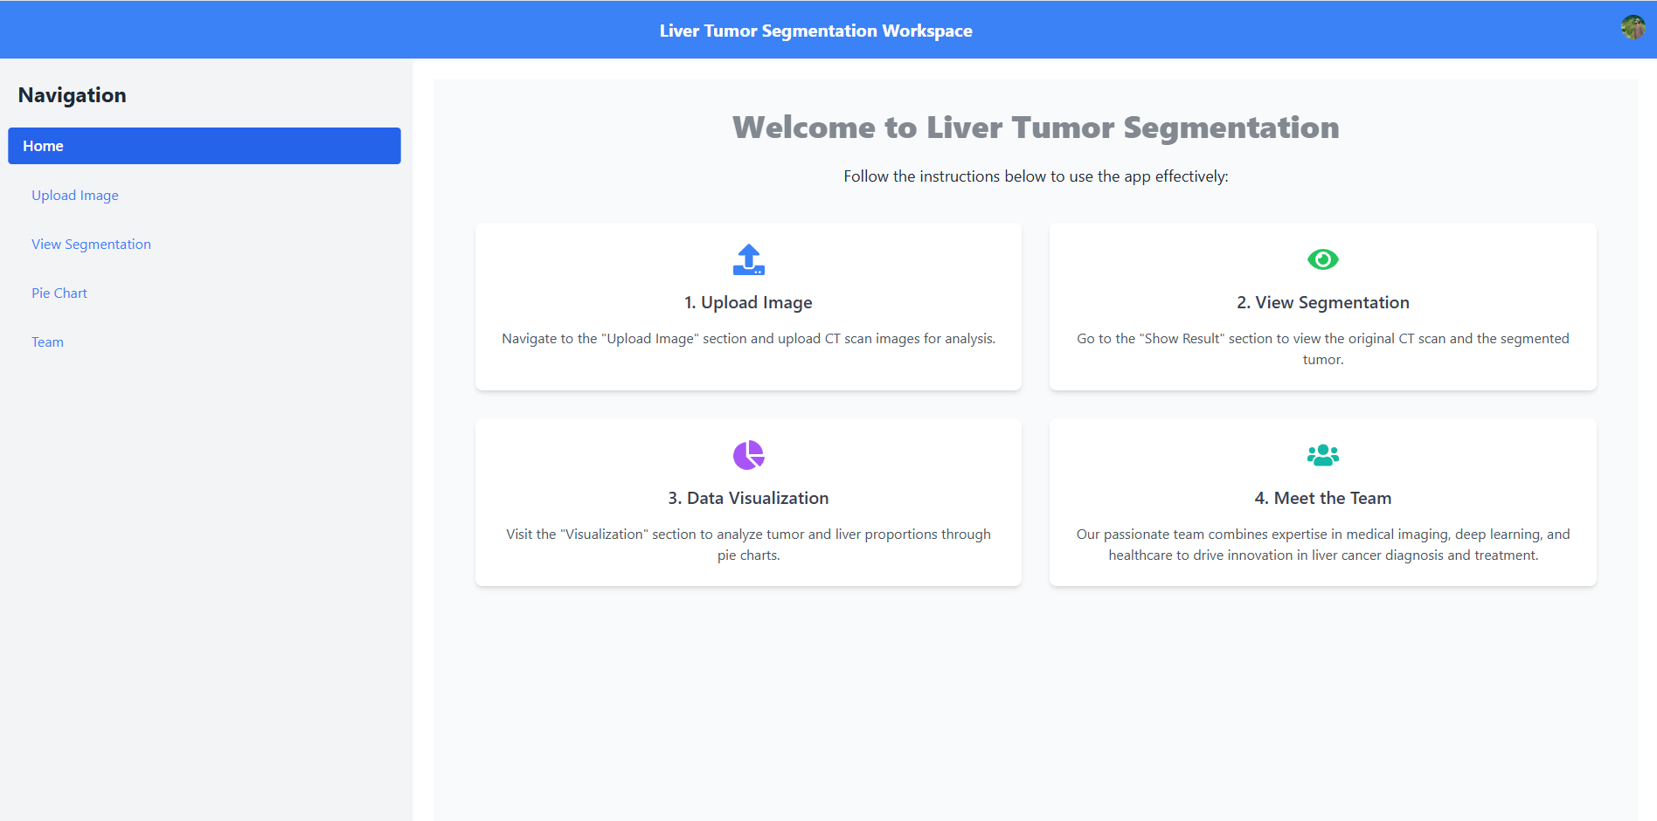

## HCI Principles

**1. Visibility of System Status**

* **What it means:** The app shows you where you are and what you can do next, so you always know what's going on.
* **Why it matters:** The headings and icons on each card give you clear, immediate information about what you're supposed to do.

**2. Match between System and the Real World**

* **What it means:** The app uses words and icons that make sense to you, based on what you already know.
* **Why it matters:** Familiar terms like "Upload Image" and simple icons (like a file upload or an eye) make the app easy to use because it aligns with what you expect.

**3. Consistency and Standards**

* **What it means:** The design stays the same throughout the app, so everything feels familiar and easy to understand.
* **Why it matters:** The consistent layout and icon styles make the app predictable, which makes it easier for you to use.

**4. Aesthetic and Minimalist Design**

* **What it means:** The design is simple, clean, and easy to navigate, with plenty of space and only the necessary information.
* **Why it matters:** A clear, uncluttered design helps you focus on the important tasks without distractions.

# Upload Image Page

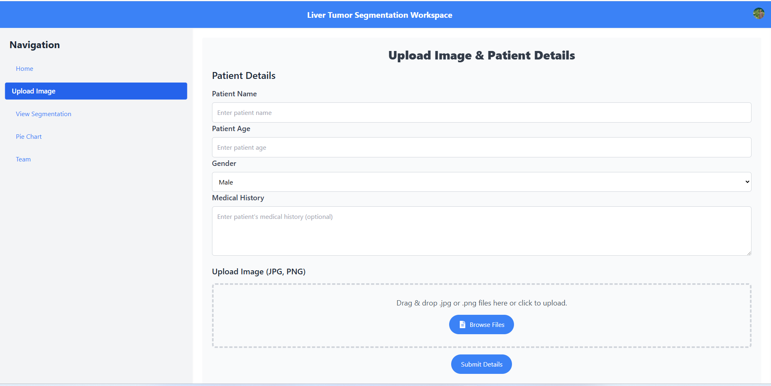

## HCI Principles

**1. Visibility of System Status**

* Provide immediate feedback after actions, such as uploading a file or submitting details.
* Example: Display a spinner or progress bar during file uploads and a confirmation message after submission.

**2. Match Between System and the Real World**

* Use clear labels like "Patient Name" and "Drag & drop .jpg or .png files here" to match user expectations.
* Replace technical terms (e.g., "Submit Details") with simpler phrases, if needed, like "Save Patient Info".

**3. User Control and Freedom**

* Implement undo/redo functionality (already in place) for modifying patient details.
* Allow users to clear uploaded files or reset the form.

**4. Consistency and Standards**

* Ensure consistency in button styles and layout.
* Use standard icons (e.g., FaFileAlt) and consistent wording like "Browse Files" across the app.

**5. Error Prevention**

* Validate file types before upload and provide descriptive error messages.
* Add placeholder text for mandatory fields to guide users on what to enter.

**6. Flexibility and Efficiency of Use**

* Support keyboard shortcuts (like Ctrl+Z for undo and Ctrl+Y for redo).

**7. Aesthetic and Minimalist Design**

* Avoid unnecessary information or elements. Keep the interface clean and visually appealing.
* Use animations (e.g., animate-pulse on the heading) sparingly to maintain simplicity.

**8. Help Users Recognize, Diagnose, and Recover From Errors**

* Show error messages like "Invalid file type. Please upload a .jpg, .jpeg, or .png image" prominently.

# View Segmentation Page

## HCI Principles

**1. Visibility of System Status**

* Actions like zooming or opening images give immediate feedback, so users know what’s happening.

**2. Match Between System and the Real World**

* Common actions like "click to enlarge" and "zoom in/out" mimic real-life behaviour, making it intuitive.

**3. User Control and Freedom**

* Users can close the modal anytime with the **"X" button** or the **Escape key** and adjust zoom levels easily.

**4. Consistency and Standards**

* Buttons, animations, and layouts follow standard patterns, so users know what to expect.

**5. Error Prevention**

* Zoom limits stop users from zooming too much or too little, avoiding confusion.

**6. Recognition Rather Than Recall**

* Visible buttons and clear labels like **"Zoom In"** make actions obvious without needing to remember anything.

**7. Flexibility and Efficiency of Use**

* Beginners see helpful buttons, while advanced users can quickly use the Escape key to close the modal.

**8. Aesthetic and Minimalist Design**

* The design is clean and focused on essential elements, like images and zoom buttons.

**9. Help Users Recognize and Recover from Errors**

* Users can adjust zoom or drag images back into place if they make a mistake.

**10. Help and Documentation**

* Simple instructions, like **"Click on images to view them in full screen"**, guide users without extra effort.

# Visualization Page

## HCI Principles

1. **Consistency and standards**:

* The chart elements use consistent color coding (red for tumor, blue for liver) to maintain clarity and standardization.

1. **Error prevention**:

* The pie chart automatically ensures that the sum of the two values (tumor and liver) always equals 100%. This prevents user errors like entering values that add up to more than 100% or less than 100%.

1. **Aesthetic and minimalist design**:

* The interface is clean and simple, focusing only on the essential elements: the chart.

# User Profile Page

## HCI Principles

**1. Visibility of System Status**

* **Feature**: The user should see their status (e.g., logged in, pending tasks) and updates in real-time.
* **Example**: A loading spinner or progress bar when updating profile information.

**2. Match Between System and the Real World**

* **Feature**: Use familiar labels and icons that match the user's real-world understanding of a profile page.
* **Example**: Common labels like "Name", "Email", "Role" for clarity.

**3. User Control and Freedom**

* **Feature**: Users can easily make changes to their profile, and undo or cancel actions if needed.
* **Example**: A "Save" and "Cancel" button that allows users to either apply or revert changes.

**4. Consistency and Standards**

* **Feature**: Use consistent design elements across the profile page and other sections of the application.
* **Example**: Same buttons, font styles, and color schemes used throughout the site.

**5. Error Prevention**

* **Feature**: Validation checks to avoid common user errors like entering incorrect email formats.
* **Example**: Real-time validation on input fields with error messages (e.g., “Please enter a valid email address”).

**8. Aesthetic and Minimalist Design**

* **Feature**: The page design should be simple, clean, and avoid unnecessary elements.
* **Example**: A profile layout with only the necessary fields and buttons visible, ensuring a clutter-free interface.

# Sign in Page

